Hello here I will go over the most important features of this code and application
Also check the “code snapshots” folder to see some of the key pieces of code of this project.
Flightbooker
This is merely an educational project, though an elaborate one, with no real world usage potential. The assignment required me to use the ASP.net Core MVC fullstack webapplication development method to build a mock flight ticket booker. It needed to be able to book (fake) flights between 8 cities with potential layovers.
The most important qualities of this projects are it’s overall setup. Model View Contoroller web development style, multilayered architecture with a layer for front end and layer that interacts with database using DAOs. The project, with the use of View Models takes care to curate the information coming from the entities in the database. Lastly Dependency Injection is used for efficient linking of code elements.
Individual features/components:
Flights:
At least one flight needs to arrive in every city every day.
Flights are first all created in a separate project “Databasefiller”. The code will take a random arrival time for each city and pick a random city that will be the original destination of this flight or series of flights if layovers are needed. So for example, the flight to Tokio for any given day is scheduled from a random departing city. it will then look for which flights are necessary to connect those cities in a table in the database. It will then create each flight with 3 hours in between.
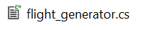
Flight searching:
Each flight has been put into the database as either as a direct flight or part of a journey. This does mean that no new routes can be calculated with the flights that are scheduled, the part they play in a journey with layovers is predetermined.
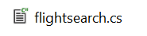
Authorisation:
ASP.net authentication is implemented so a user can log in and his booking and shopping cart information can be remembered.
Shopping cart:
Given the user is logged in they can add the flights from the flight searcher to the shopping cart, or remove them. The user can start their booking process both directly from a search result or their shopping cart
Booking history:
given a user is logged in this tab displays their bookings and labels them as confirmed, cancelled or pending. Allows the user to make adjustments (food selection) or cancel them (if not too late)
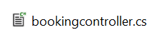
Meal selection:
The meal for each flight for each journey can be selected and edited.
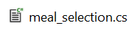
Seat number and class:
For each flight a fixed number of seats of both economy and business class are kept in the database, if the number of booked seats have reached the maximum, no journeys that contain this flight will be displayed when searched, or when part of a shopping cart, will not allow them to be booked. Every flight ticket is assigned a seat number
Promotional banner:
A banner is displayed at the flight searching page that advertises a random city or when a user is logged in, the most often booked flight of that user.
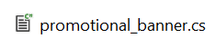

Website Screenshots:
Seaching page
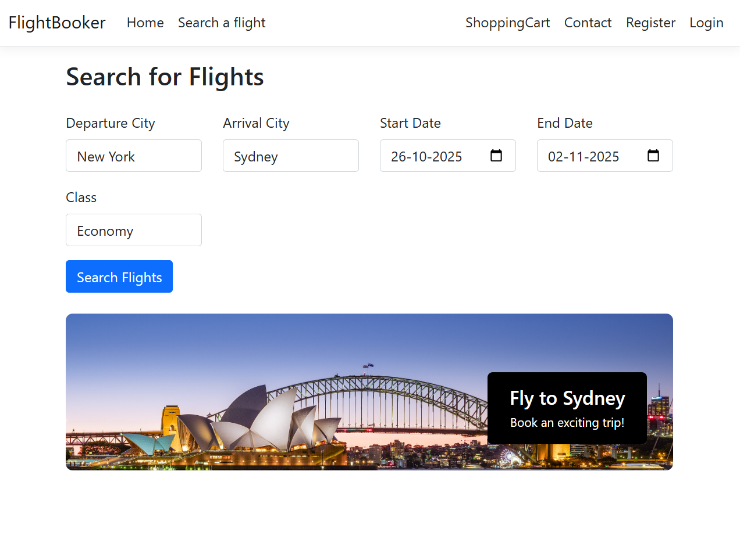

Search results page:

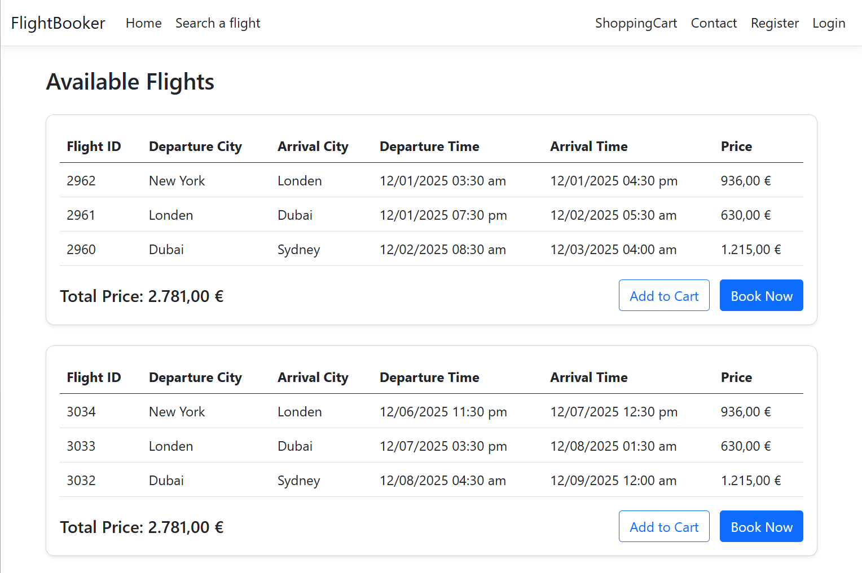

Meal selection page:
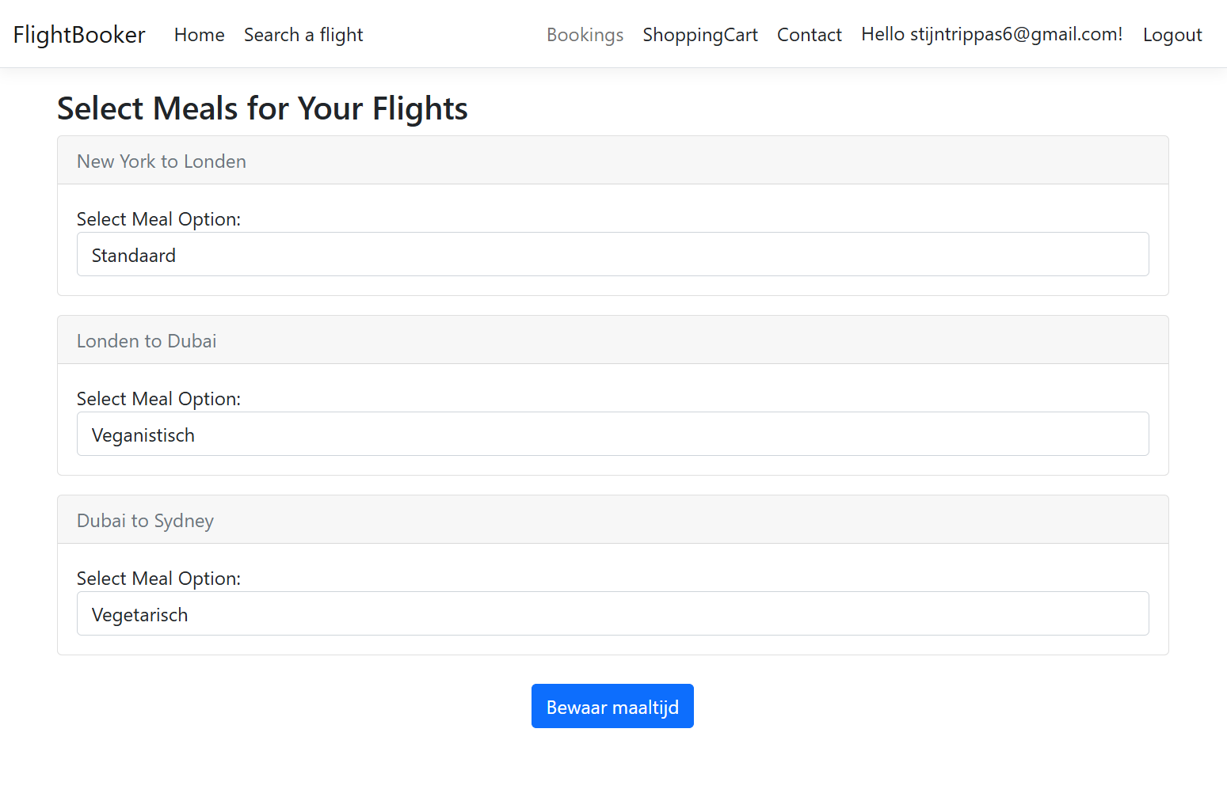
Booking history page:
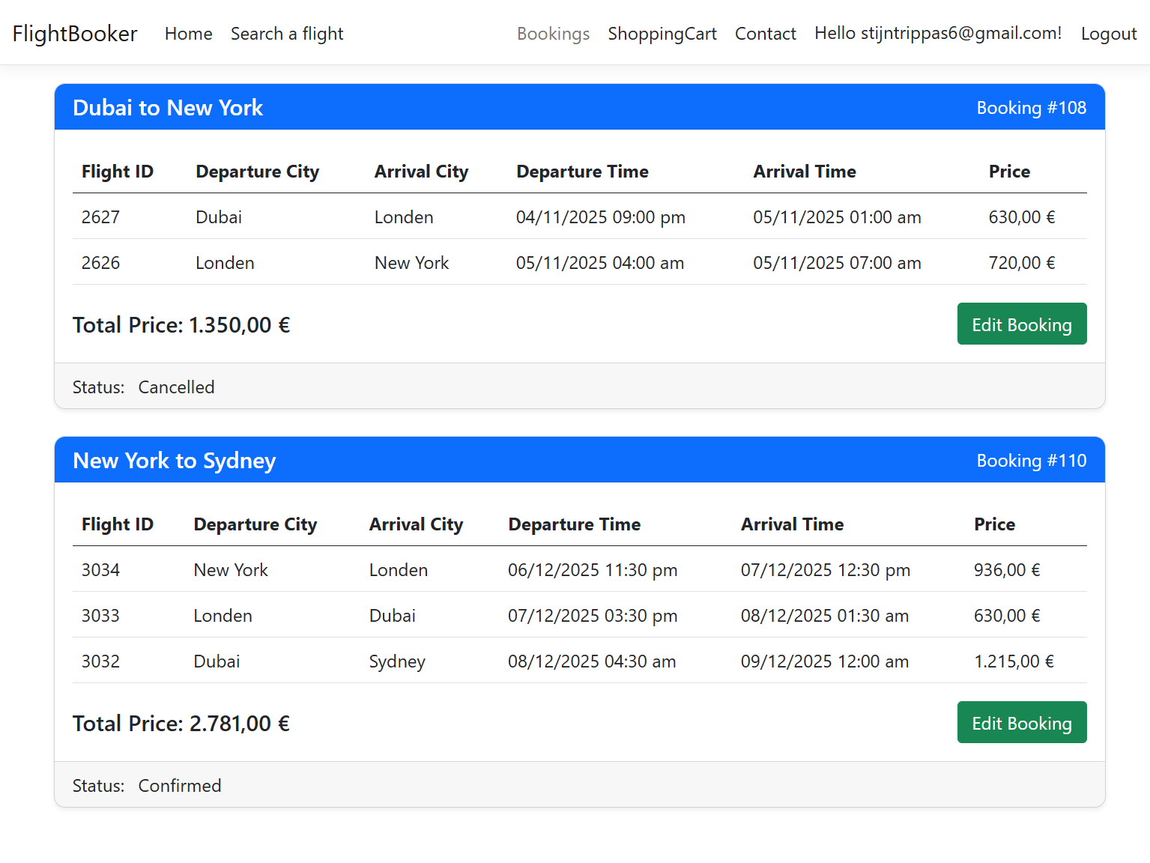
Database diagram:
